Your ref:
Please Reply To: Senior Information Governance Officer
T 01924 306112
E: freedomofinformation@wakegield.gov.uk

Date: 2 June 2026

Transformation Directorate
Service Director: Emma Marshall
Wakefield One
Burton St
Wakefield
WF1 3EB
Typetalk calls welcome

Contact: Senior Information Governance Officer

T 01924 306112

E: freedomofinformation@wakegield.gov.uk:

Typetalk calls welcome
From a textphone dial: 18001 0345 8 503 503
From a telephone dial: 18002 0345 8 503 503

Dear Requester,

Environmental Information Regulations 2004 - Request for Information
REF: EIR 395

I am writing in respect of your enquiry for information held by the Authority, which has been processed under the provisions of the above Regulations. Please note that, as previously advised, the EIR legislation is relevant, as your request relates to issues which affect the environment.

Please find the response to your request below.

Could you please provide some information regarding the Kirkgate Regeneration Project currently being progressed in Wakefield,

1/ Purchase price of the old ABC Cinema, Kirkgate and the date purchased and who the building was purchased from and also confirm if Council or Government monies were used for the purchase. . The old ABC cinema leasehold was purchased on 24th August 2020 from Salim Ibrahim Patel for £850,000.00 plus VAT using Towns Fund grant funding.

2/ Purchase price of the old Wilko, Kirkgate and the date purchased and who the building was purchased from and also confirm if Council or Government monies were used for the purchase. The old Wilko site was purchased on 10th January 2024 from Wakefield Real Estates (No 1) Limited and Wakefield Real Estates (No 2) Limited for £2,500,000.000 plus VAT using Town Fund grant funding.

3/ Full costs breakdown to date of demolition and site clearance of the ABC and Wilko sites and how this was funded ie. Government or Council monies.
ABC
Town Deal grant £1.003m
Council funded £0.616m
Total £1.619m

Wilko
Town Deal grant £0.285m
Total £0.285m

4/ Confirm if the Council currently owns all the cleared site at Kirkgate, if it doesn't then please confirm the date and purchase price when the freehold was transferred to VICO Homes. The Council currently owns the land edged red on the plan below.

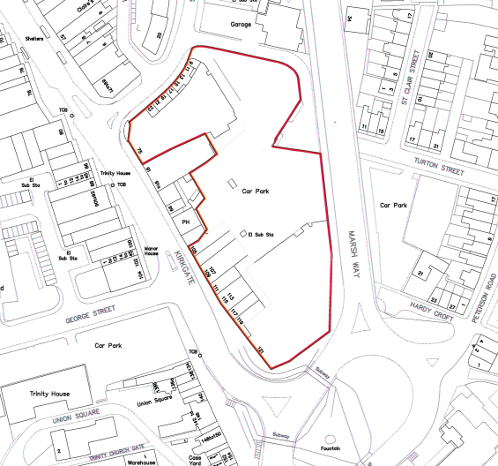

5/ Confirm the total amount of Section 106 monies the Council will be providing to VICO Homes for the Kirkgate development. Section 106 agreements are made between a local planning authority and a landowner when granting planning permission. As no planning application has been made to date Section 106 is not relevant to this site.

6/ Confirm if any compulsory purchases have been or will be required to progress the Kirkgate development, if so could you please provide a full cost breakdown to date and if this is funded by Government or Council monies. No compulsory purchases have been made and none will be required.

I trust that this information is satisfactory for your purposes.

If you are not satisfied with the way the Authority has handled your request, you may ask for an internal review. Please contact:

Senior Information Governance Officer
Corporate Information Governance Team
County Hall
Wakefield
West Yorkshire
WF1 2QW
Or email: freedomofinformation@wakefield.gov.uk

Yours Sincerely,

Senior Information Governance Officer
Information Governance Team,
Wakefield Council
E-mail: freedomofInformation@wakefield.gov.uk
Tel: 01924 306112

